Virtual Choirs﻿
September 22, 2020 Gaile Stephens Ensembles, Teaching Music Online, Trends 0

Student Thoughts on Taking Performance Online
By NAfME Members Bobby Olson and Scott N. Edgar
Reprinted with permission from Music in a Minuet Blog https://nafme.org/virtual-choirs/
If your social media feed is anything like mine, it has been inundated with discussions about virtual choirs. Some choir directors are pulling together incredible productions while others are, understandably, leery of the undertaking. This trend began with Eric Whitacre’s highly successful (and technologically-advanced and well-resourced) endeavor.
The immediate effect of social distancing and eLearning was a loss of our concerts and festivals. Like many of you, I felt angry, disappointed, and sad. The loss of musical collaboration towards a celebratory end sent me through waves of grief. In the grand scheme of things, a canceled concert or festival is not critical, but I think it is still important to acknowledge our emotions before we try to lead our students through them. This year we have been working to increase the self- and social-awareness of our students by implementing a Social-Emotional Learning curriculum through the choral music education classroom. This level of navigating emotion has required every ounce of the skills we have tried to build this year, for students and teachers alike.
Our students have lost their routines, their socialization, the events they have dreamed of for years. Some are reeling. They miss their friends. They miss the daily escape of the choir room. They wanted to perform as much as we wanted them to perform. But some are relieved. The rigid bell schedule is gone. They get to avoid that kid they do not get along with. They can just sing the music they want to when they want. They do not have to go on that stage that can be so anxiety-producing.
The knee-jerk performance replacement for a concert or festival is the virtual choir. It looks so cool! It sounds amazing! It will impress all of our administrators, choir director friends, and families! Our students will have that performance opportunity that was taken from them. However, as we have come to realize, this is much more work than an in-person choir. It is more complicated and more sterile. It negates many of the teaching skills that we have practiced for years and requires us to master a whole new method of instruction. Instead of smiles and applause, the audience can only react to our performance with likes and shares. The end product may look/sound good, but the process—that journey that fostered our own love of music—is vastly different.
Before our music department decides whether or not to jump onto the virtual choir bandwagon, we wanted to see what our students thought. As we navigate these unique times, we believe that we are not the only experts in the room, and honoring the students’ voice is essential to providing relevant, remote music education.

Student Interest in Virtual Choirs

Some students love the idea of a virtual choir:
It shows perseverance and determination, and I think our community could use a little “pep talk” through this time to keep finding ways to do what you love and keep yourself happy.
It will be very difficult, but a challenge that we are capable of. Pushing our own musical ability to properly sing in tune and rhythm without people around to help us.
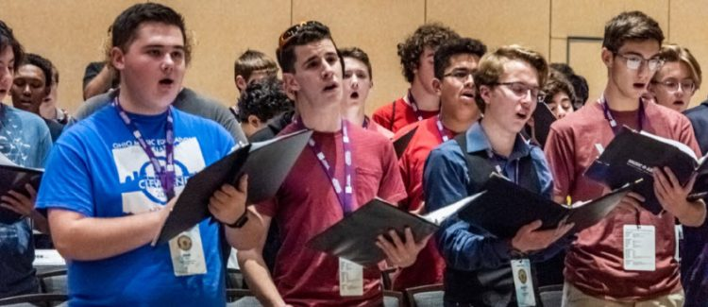Photo: Bob O’Lary
Yes! I feel like it would be really cool to do a virtual choir at a time like this because it’s like we’re showing that this social distancing thing isn’t going to stop us from using our voices.
Yes! This is so cool, and I think it would really show our dedication to music, in times like these where we can’t physically come together.

Not all students were in favor of a virtual choir:
No because of all the internet difficulties, and there is always lag, along with everyone sounding different on video call.
No, because it takes away the feeling and the purpose of listening to a live choir and the rush of it.

Some saw both sides:
I think it’s a cool idea. I would feel weird because I’ve never done anything like this, but trying would be fun.
I think it would be cool, but it’s not something that really interests me. I feel like I’d personally feel a little awkward.

The Challenges of a Virtual Choir from the Student Perspective
The students realized that there are challenges involved in the creation of a virtual choir that go beyond the polished videos appearing on social media. The social and emotional ramifications were articulated more prevalently by the students than the technological challenges.
I think the biggest challenge would be people not feeling confident singing by themselves and sending a recording.
I think some might be too shy to record themselves.
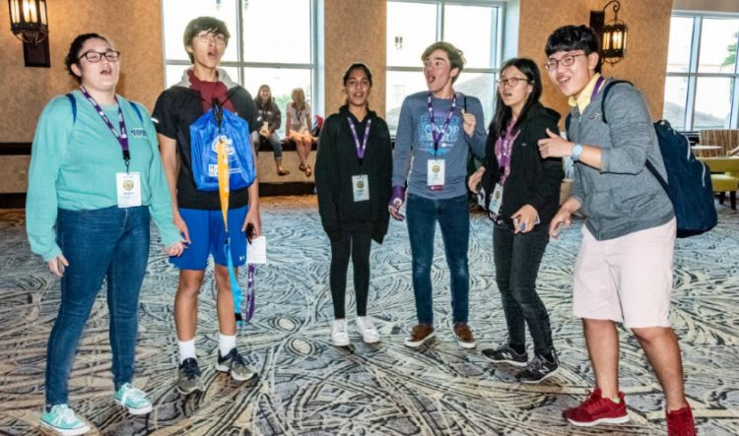Photo: Bob O’Lary
I think a challenge would be getting everyone to do their part and really perform in a different setting since not everyone would be down with the idea and would not want to.
Maybe they don’t have any quiet space in their home, or they don’t have access to the internet, or even to find a way for all of us to be on a single call.
Not having the guidance of our directors there. Or, being able to make sure that all the ensemble’s voices match and flow together.

Would a Virtual Choir Help Maintain Our Choir Community?
Students are longing for their choir community. There were mixed opinions regarding whether or not a virtual choir would help fill this void.

Virtual is better than nothing:
I feel empty without choir. It would be a nice way of saying: “Hi, I’m still here”
Music is something that pretty much everyone can find a connection with, and doing something like this can show people that if a bunch of teenagers aren’t giving up something we love because of the quarantine, neither should you. There is always a way to practice what you love. Music helps us connect to each other, what better way for our community to come together than through beautiful music.
It would make me feel connected to the community because it will show the determination we have as a choir to perform for others even in times of need.
I miss getting to come to choir, and doing this would feel like reconnecting with everyone again and just might spark some of the happiness I’ve felt in choir again.
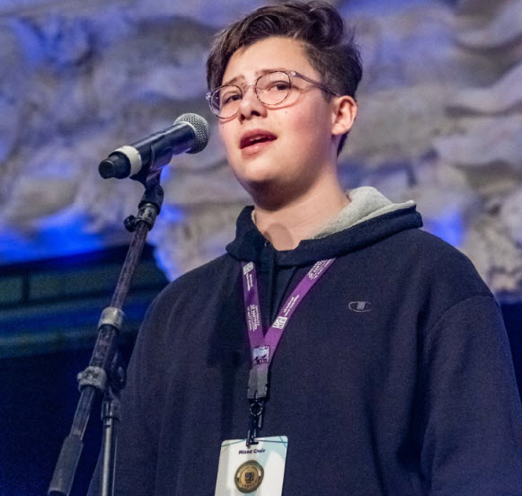Photo: Bob O’Lary
It would help because being in choir and singing to make music has been greatly missed. Doing something like this would be a good way to get everyone together even without leaving our homes.
We’re still creating music, just on a different level.

Virtual connection would not be socialization for everyone:
I prefer being with everyone in person. It doesn’t have that same energy as in doing the performances in real life.
No, because we can’t communicate or discuss our opinions like we do in class.
No. There is no sense of community or togetherness; it just fills up empty space.
No because it makes me feel even more lonely knowing that everyone is stuck in their houses and no one can go out. I miss school.

To Go Virtual or Not?
So, how do we respond to our students in a way that honors what they want out of their education? At this uncertain point, we are going to attempt to replace the things that our students have lost. We will tele-conference to see each other’s faces. We will provide music theory lessons and sight-reading apps to enhance their musicianship. We will send out practice tracks to emulate rehearsal and funny screencasts to capture their attention. We will try to do everything we can to promote singing and connection in the midst of silence and distancing. In the end, we may even compile the tracks and videos into a virtual choir. But this alone cannot “fill the void.” Just like good music education is not just about the concert, remote music education cannot be just about the virtual choir. Whether or not we create a virtual choir, we will focus on our students’ needs and their journey.
“Just like good music education is not just about the concert, remote music education cannot be just about the virtual choir.”
It is our goal to build resiliency and empathy through choral experiences. For some, replicating the in-person experience will be the most meaningful; for others, some sort of performance will meet their needs and demonstrate community and resilience. However, through discovering and hearing our students’ thoughts, we realized only creating a virtual choir is not enough to replicate what makes our classrooms special—coming together to make music with those who mean so much to us.
Special thanks to Matthew Weber and Alexa Andrews for their help in organizing the student responses.
About the authors:

Bobby Olson has taught choir at Round Lake High School in Round Lake, Illinois, since 2015. He previously taught at King’s Schools in Seattle, Washington, and Cambridge Lakes Charter School in Pingree Grove, Illinois. He received his BA with an emphasis in Music Education from Augustana College (IL) and MMed from VanderCook College of Music. He is a member of the National Association for Music Education. He lives in Third Lake, Illinois, with his wife, Dana, their son, Andy, and energetic dog, Phinney.

Dr. Scott N. Edgar is in his eighth year as Associate Professor of Music, Music Education Chair, and Director of Bands at Lake Forest College. He received his Doctorate of Philosophy in Music Education from the University of Michigan, his Masters degree in Education from the University of Dayton, and his Bachelor of Music in Music Education degree from Bowling Green State University. His previous teaching experience in higher education includes work at Adrian College and Concordia College Ann Arbor. Prior to his work in higher education, he taught K–12 instrumental music in Ohio and Michigan. Dr. Edgar is the author of Music Education and Social-Emotional Learning: The Heart of Teaching Music and is an internationally sought-after clinician on the topic. In addition to clinics, he also teaches graduate courses on Musical Social Emotional Learning at VanderCook College of Music. He is an active clinician and adjudicator for both concert band and marching band and regularly presents at professional development and research conferences. Dr. Edgar is a Conn-Selmer Educational Clinician and VH1 Save the Music Foundation Educational Consultant. Dr. Edgar is a member of the National Association for Music Education, the American Educational Research Association, the College Music Society, Phi Mu Alpha Sinfonia Music fraternity, and Kappa Kappa Psi Band fraternity. He lives in Lake Villa with his wife, Steph, their son, Nathan, and their cats, Elsa and Wolfie.
Did this blog spur new ideas for your music program? Share them on Amplify!
The National Association for Music Education (NAfME) provides a number of forums for the sharing of information and opinion, including blogs and postings on our website, articles and columns in our magazines and journals, and postings to our Amplify member portal. Unless specifically noted, the views expressed in these media do not necessarily represent the policy or views of the Association, its officers, or its employees.

